**Create Account**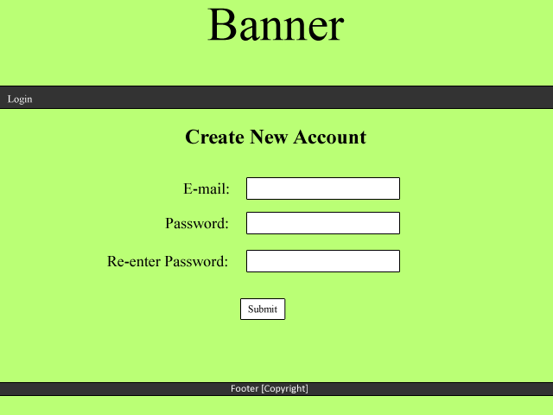

Once the user has entered their email and passwords, it will then be added to the database once the submit button is clicked.

This will direct the user to the “Login” page, to where they can log in.

**Login**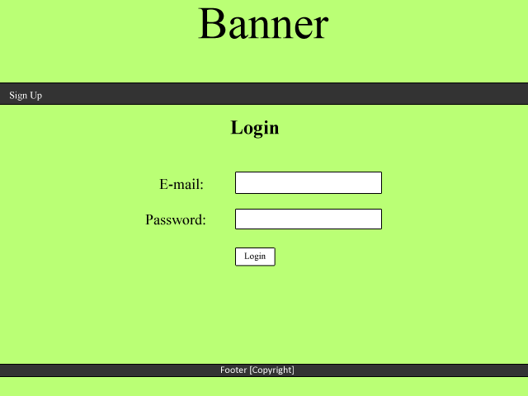

Non-registered users will click this to sign up. This will navigate the user to the “Create Account” page.

If the credentials are correct, they will be directed to their homepage. If the credentials do not match, an error message will appear.

The email and password that the user signed up with will be their credentials to login with. Regular expressions will be used for the email.

**Cash Pile**

It is one of the requirements for the friends list to be ranked and this can be done by the highest amount of money. Each user will be sorted from richest – poorest on the homepage.

**Banner**

Each page will have a banner which will be a design (text/image) saying 'Monster Mash'.

**Menu Bar**

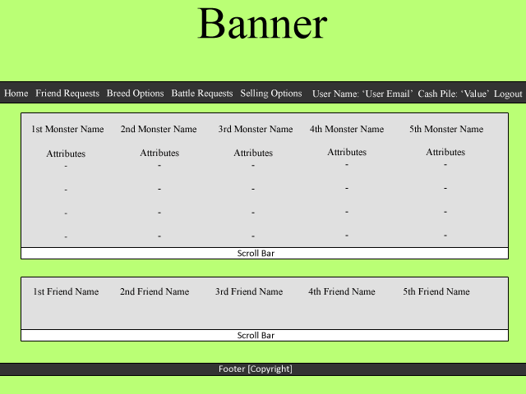

**Home:** Links to the “Home” page.  
**Friend Requests:** Links to the “Friend Requests” page.  
**Breed Options:** Links to the “Breed Options” page. **Battle Requests:** Links to the “Battle Requests” page.  
**Selling Options:** Links to the “Selling Options” page.  
**User Name:** This will display the email of the user which is currently logged in.  
**Cash Pile:** This will display the user’s cash pile.  
**Logout:** This will end the user’s session.

**Homepage**

The user’s monsters will appear here and will have the monster’s name and attributes.

The user’s friends will appear here and will be sorted by wealthiest (by “cash pile”) to poorest. The user will be able to click on a friend which will direct them to the selected friend’s page.

For cases where the user has a lot of monsters/friends, a scroll bar is used so they can view the objects that don’t fit on the screen.

**Friend’s Page**

**Friend’s Page**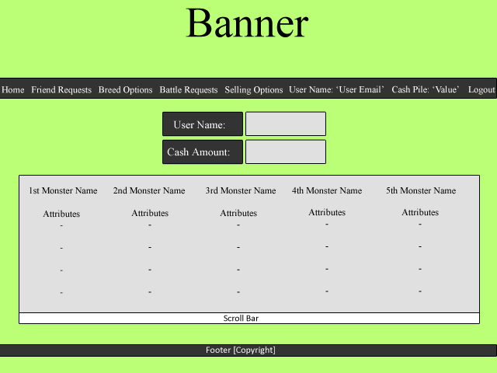

The monster’s belonging to the friend will appear here.

The selected friend’s user name will show here as well as their cash amount.

**Battle Requests  
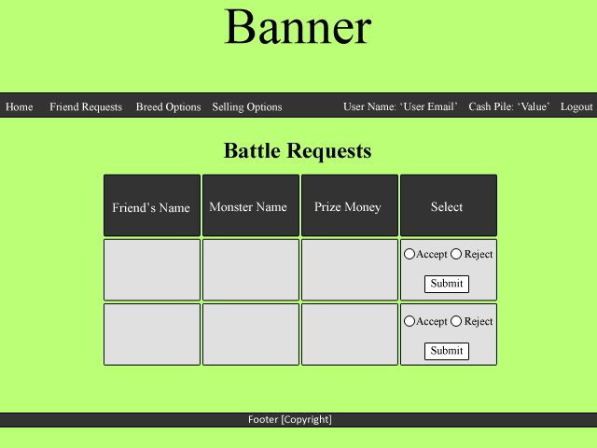**

Each victor will receive prize money; which will appear in this column.

The user will have the option to choose to accept or reject the request.

The monster that the friend is requesting to battle with will appear in this column.

The name of the friend requesting for battle will appear in this column.

**Breed Options**

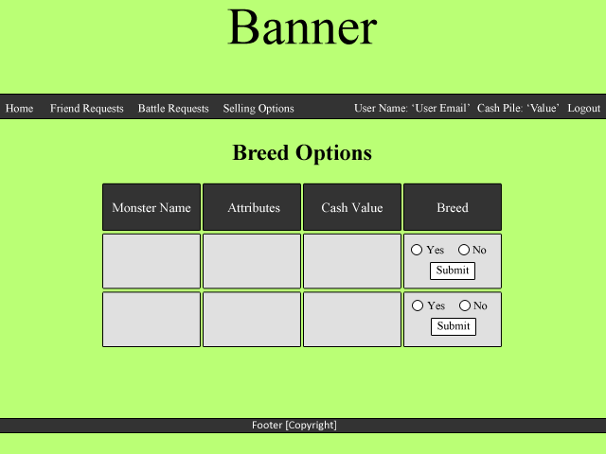

The user will be able to choose what monster they want to breed with.

The cash value to breed with will appear here. The user will pay this value if they choose to breed with that monster.

The monster’s attributes will appear here.

The name of the monster that is on offer to be bred will be shown in this column.

**Selling Options**

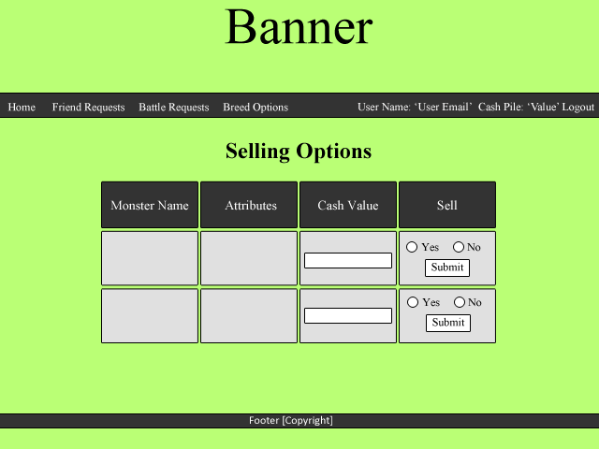

The user can add a cash value to the monster which will represent the sale price.

The monster’s name will appear in this column.

The monster’s attributes will appear here.

The user will be able to choose to sell the monster from this field.

**Battle Report**

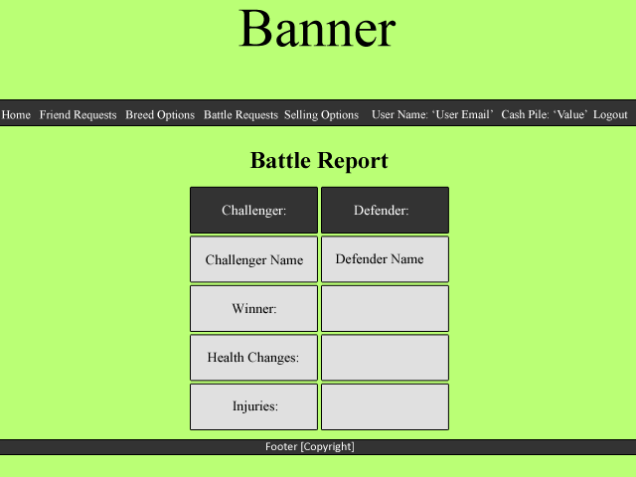

Monster injuries from the battle will appear here.

The remaining health of the monster will appear here.

The winner of the battle will be shown here.

The names of the contestants will appear here.

These headings represent which side the challenger and defender are.

**Friend Requests**

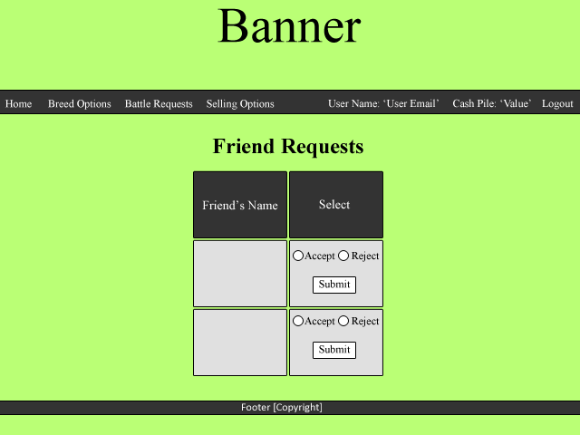

The user will be able to accept or reject the request to friend. Accepting will add that friend to their friends list.

Each request to friend will appear here, with that friend’s name.